
0

TITLE
Smart Object Finder: A Safety and Mobility Enhancement Tool for the Visually Impaired

AUTHORS
Muhammad Irsyad Hazim bin Rozaini, Nur Husna Elysa Maisarah binti Rosli, Aizzul Luqman bin Khairul Anuar, Department of Mechatronics Engineering, International Islamic University Malaysia, Email:

ABSTRACT
This project presents the development of a Smart Object Finder designed to assist visually impaired users in locating everyday objects through intelligent vision and distance feedback. The system integrates HuskyLens AI-based object recognition with an ultrasonic (supersonic) sensor to provide real-time distance estimation. The architecture is divided into two main systems. System 1 functions as the user interface and communication system, allowing users to select target objects either through physical push buttons or via a smartphone using Bluetooth communication. System 2 serves as the sensing and feedback system, where object detection, distance measurement, and audio feedback are processed. In addition, a Telegram bot is integrated to store detection history data, enabling review and monitoring of system usage. The inclusion of ultrasonic ranging and cloud-based history logging significantly enhances spatial awareness, usability, and system intelligence, making the proposed solution suitable for real-world assistive applications for the visually impaired.
- INTRODUCTION
Visual impairment significantly affects an individual’s ability to interact independently with their surrounding environment. Simple daily tasks such as locating personal belongings can become time-consuming, frustrating, and potentially unsafe without appropriate assistance. Conventional mobility aids, including white canes, primarily focus on obstacle detection and ground-level navigation. While effective for mobility, these tools do not provide object-specific identification or spatial information related to everyday items, limiting their usefulness in object-finding tasks.
Recent developments in assistive technology have introduced vision-based systems that utilise artificial intelligence (AI) to recognise objects for visually impaired users. Although such systems improve object awareness, many rely solely on visual recognition and lack accurate distance estimation. As a result, users may know that an object exists but remain uncertain about its proximity, reducing search efficiency and user confidence. Furthermore, limited interaction methods and absence of usage data logging restrict the adaptability and intelligence of existing solutions.
To address these limitations, this project proposes a Smart Object Finder Assisting the Blind that integrates AI-based object recognition with ultrasonic (supersonic) distance measurement, flexible user interaction, and cloud-based data logging. The system employs a HuskyLens AI camera to detect user-selected objects and an ultrasonic sensor to estimate the real-time distance between the user and the detected object. Audio feedback is provided through a buzzer to guide the user based on proximity.
In addition, the system introduces a dual-mode user interface that allows object selection either through physical push buttons or via a smartphone using Bluetooth communication, improving accessibility and ease of use. A Telegram bot is also integrated to log detection history data, enabling monitoring, future analysis, and potential system improvements. By combining intelligent sensing, intuitive feedback, and connected data management, the proposed system aims to enhance independence, efficiency, and safety for visually impaired users while demonstrating effective Mechatronics System Integration principles.
The table below compares the Smart Object Finder project with several other assistive devices (including smart canes and AI-based object finders), highlighting their detection methods, feedback mechanisms, connectivity, user interfaces, and advanced features:
Table 1 Table of comparison
Assistive System (Year) | Detection Method | Feedback Method | Connectivity | User Interface | Advanced Features
Smart Object Finder (2025) | Vision (HuskyLens AI camera; pre-trained object recognition) | Audio cues via buzzer (beeps vary by object direction/distance) | ESP-NOW  (ESP32-to-ESP32 link) | Three physical buttons (select target item) | AI-based object detection and orientation guidance (real-time feedback on item location)
Ultrasonic Cane – Dey et al. (2018) | Ultrasonic distance sensor (front-facing; ~5–35 cm range) | Buzzer alerts (beeps when obstacle detected) | None (standalone offline device) | No dedicated UI (automatic obstacle detection when powered) | Basic obstacle detection only (PIC microcontroller-based; no navigation or location features)
Smart Stick with GSM – Swain et al. (2017) | Ultrasonic sensor (front) | Buzzer+ vibration motor (tactile feedback) | GSM cellular (SMS alerts) & GPS module | Cane-mounted emergency button (to trigger help SMS) | Sends SMS emergency alerts with GPS coordinates to caregivers (outdoor navigation aid)
Vision-Enhanced Smart Stick – Pilania et al. (2021) | Ultrasonic sensors + IR camera (object recognition within ~1 m) | Speech output (audio warning messages) | GSM module (sends SOS SMS with Google Maps location link) | Built-in SOS button on stick (to contact caregiver) | Recognizes specific obstacles via infrared imaging; emergency alert with location to caregiver.
NaviSense – Sridhar et al. (2025)] | Vision (smartphone camera+ LiDAR;AI vision-language model for open-world objects) | 3D audio cues (spatial sound guidance) + haptic vibration (phone feedback) | Wi-Fi/Cellular (cloud backend for AI processing) | Smartphone app (conversational voice commands) | Conversational AI for any object query (no pre-training); real-time AR guidance to target (significantly reduces search time).
WeWALK Smart Cane (2023) | Ultrasonic sensor (detects above-ground obstacles beyond cane’s reach) | Handle vibrations for obstacle warning; audio feedback via smartphone (turn-by-turn directions) | Bluetooth to companion smartphone app | Touchpad & tactile buttons on cane handle (control smartphone app) | GPS navigation and transit info through phone app; voice assistant integration for hands-free commands; LED light for visibility.

2. METHODOLOGY

2.1 Project Development

Overall, a block diagram is used to illustrate the complete operation of the Smart Object Finder for the Visually Impaired system, showing the relationship between the input, processing, communication and output components. The project is divided into three main systems, namely System 1 (User Input and Communication System) and System 2 (Vision-Based Object Detection System). Fig. 1 shows the block diagram of System 1, Fig. 2 presents the block diagram of System 2, while Fig. 3 illustrates the flowchart that explains the working principle of the entire system.

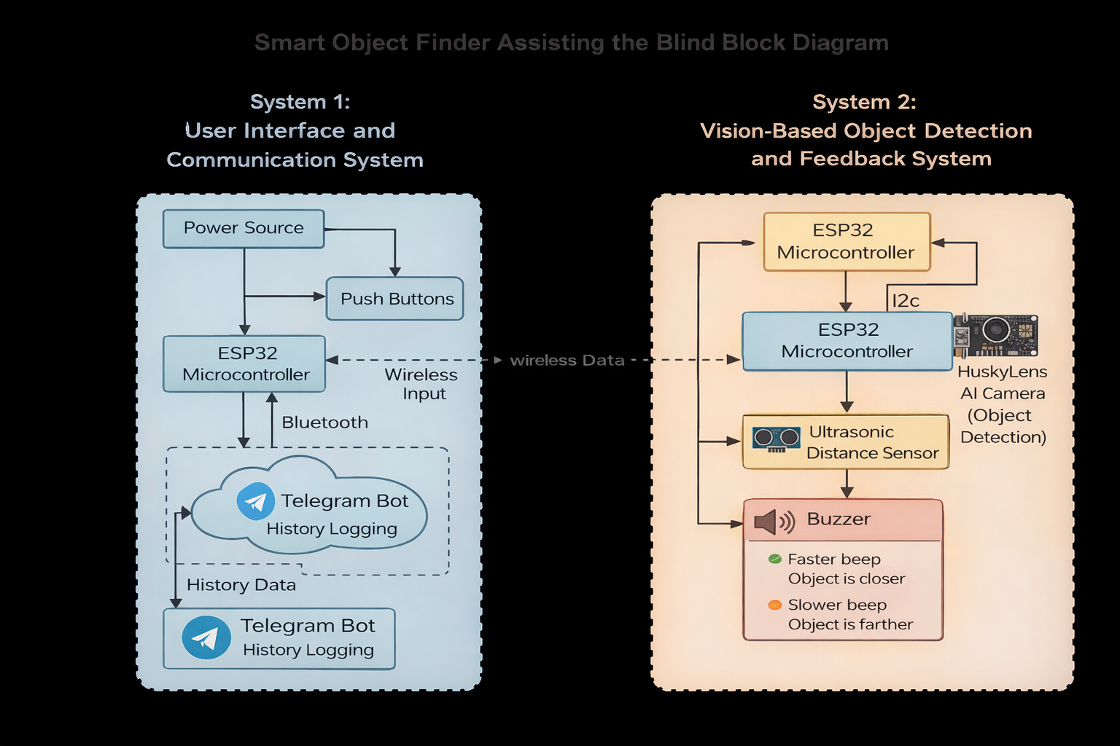
Fig. 1 Block diagram of system 1 and system 2 of the Smart Object Finder
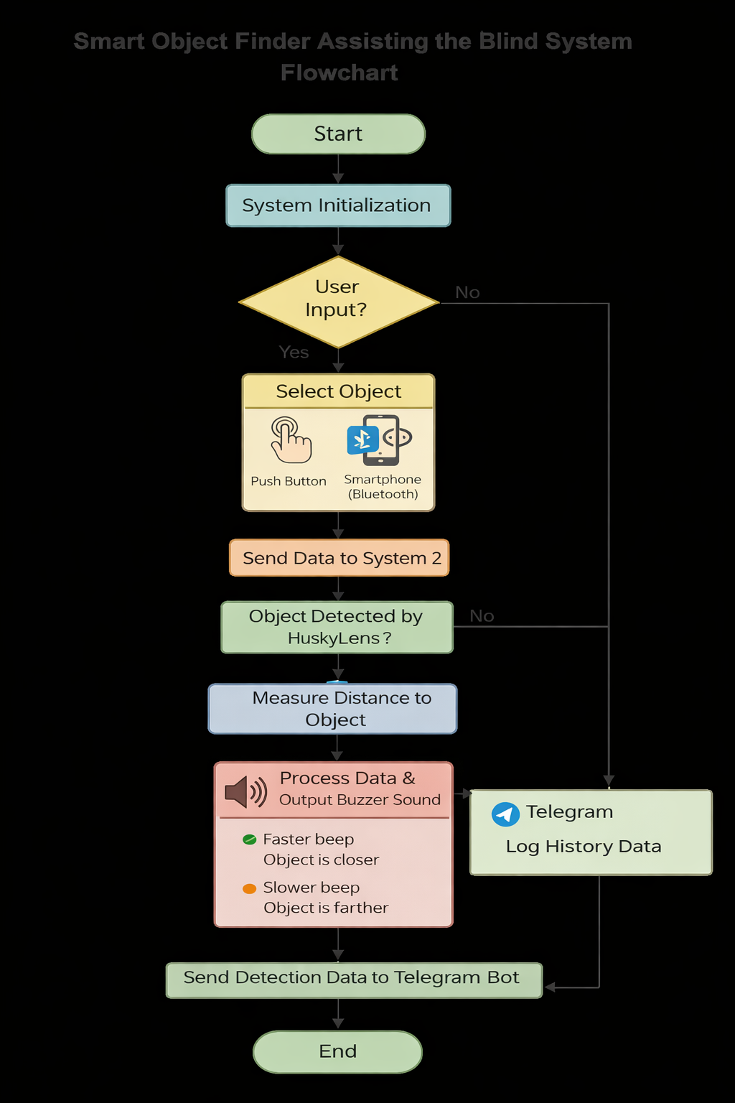
Fig. 2 The flow chart that explains all the work principles for the Smart Finder Object project.

2.2 Schematic Diagram and Prototype Setup
Figure 3 illustrates the circuit diagram of System 1, which serves as the user interface of the proposed assistive system for the visually impaired. This system consists of an ESP32 microcontroller interfaced with three push buttons that represent different lost items, allowing the user to select the desired object.

Meanwhile, Figure 4 presents the circuit diagram of System 2, which functions as the vision, sound-feedback, and object detection unit. This system comprises an ESP32 microcontroller integrated with a HuskyLens AI vision sensor, where the target objects are pre-trained and stored. Upon receiving the selected item information from System 1 via wifi (ESP-NOW), the HuskyLens detects the corresponding object and outputs its positional data, in which a buzzer module is integrated to provide audio feedback based on the distance of the detected object, thereby guiding the user during the searching process.

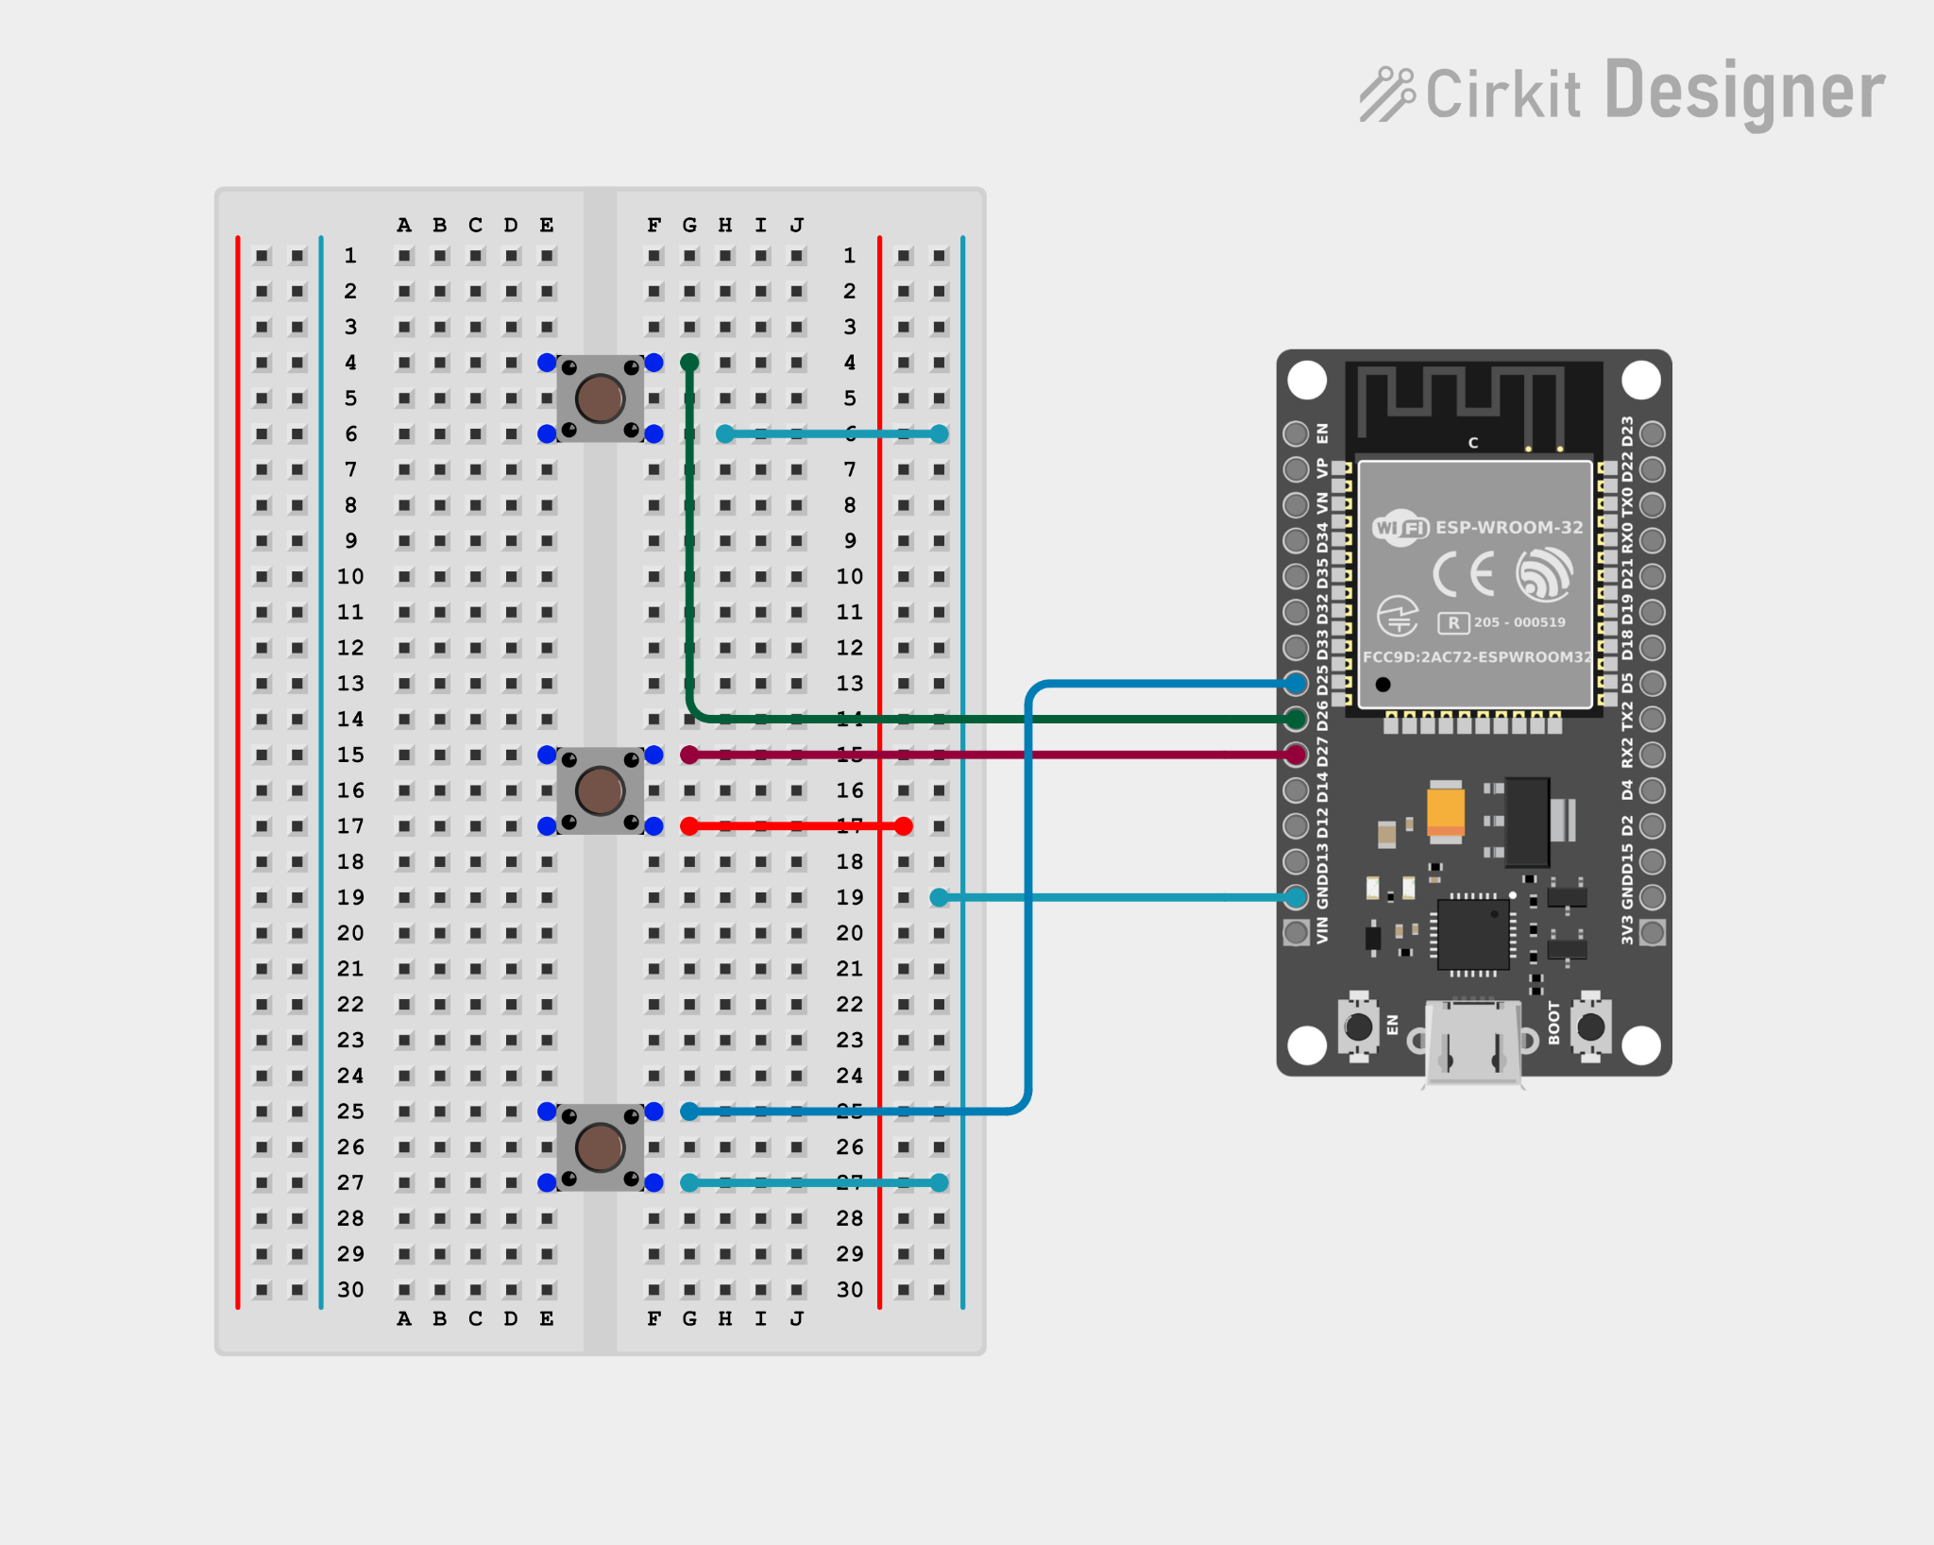
Fig. 3 Electrical Design of System 1
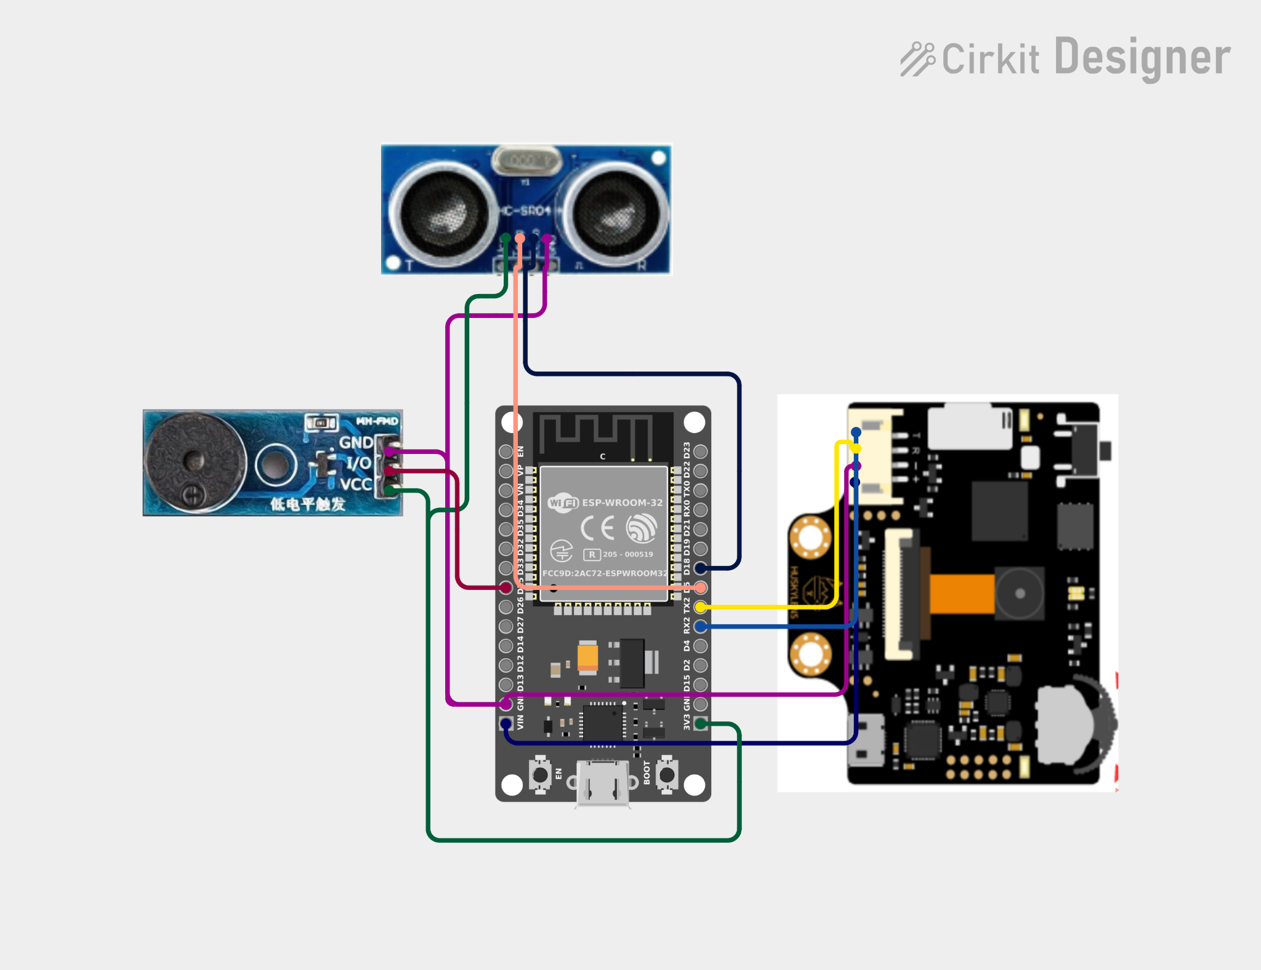

Fig. 4 Electrical Design of System 2
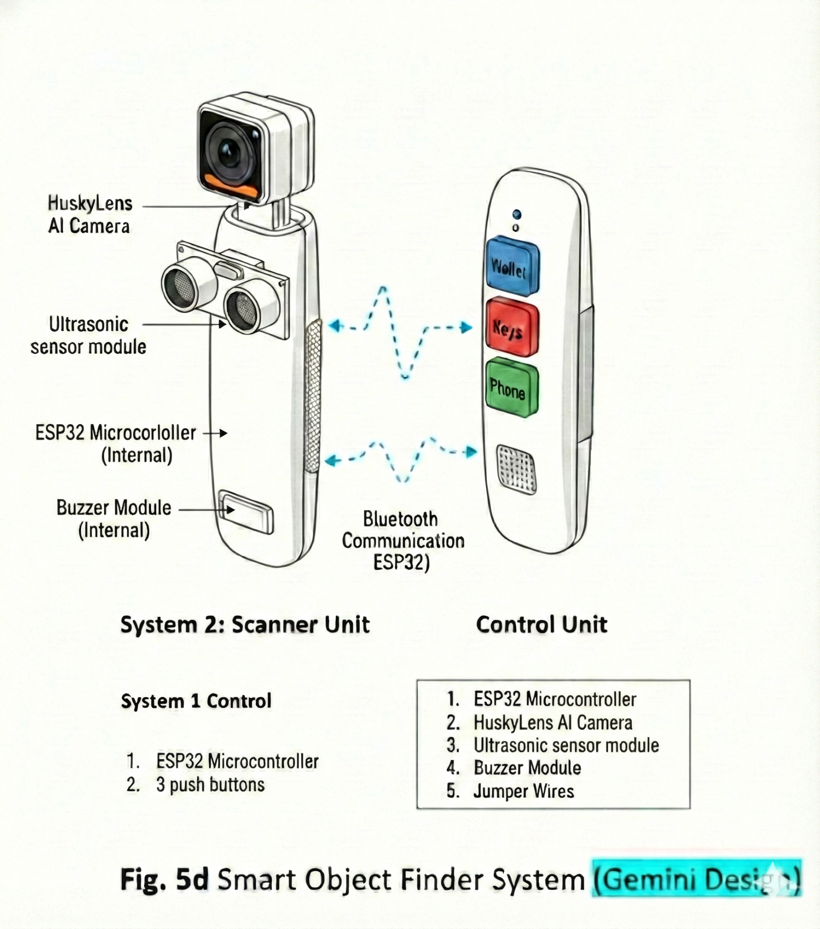
Fig. 5 Prototype Setup (Gemini)
3. RESULTS AND ANALYSIS

3.1 System 1: User Input Control Responsiveness
System 1 functions as the user input and communication interface of the Smart Object Finder. Its primary role is to allow users to select target objects and system modes through either physical buttons or a Bluetooth-based smartphone interface. The responsiveness, reliability, and usability of both input methods were evaluated to ensure suitability for visually impaired users.

3.1.1 Physical Button Control

Button Response Time

The response time of the physical push buttons was evaluated by measuring the delay between button press and command reception by the ESP32 controller. Experimental observations showed that the button response was near-instantaneous, with negligible delay perceptible to the user. This confirms that physical button input provides fast and deterministic control, which is critical for time-sensitive operations such as emergency or mode switching.

Manual Triggering
Manual triggering using physical buttons allowed users to select predefined object categories reliably. Each button press generated a single, unambiguous command, reducing the likelihood of accidental multiple triggers. This simplicity is beneficial for visually impaired users who rely on tactile feedback and predictable control behavior.

Emergency / Mode Switching
Physical buttons proved highly effective for emergency activation and mode switching. The tactile nature of the buttons allows users to locate and activate them quickly without visual confirmation. During testing, emergency or mode-change commands were successfully triggered on the first attempt, demonstrating high operational reliability.

Reliability in Offline Conditions
One key advantage of physical button control is its independence from wireless communication. Tests conducted without Bluetooth connectivity confirmed that all button-based inputs remained fully functional. This ensures that the system remains operational in offline conditions or environments with wireless interference, making physical buttons a dependable fallback input method.
3.1.2 Bluetooth Control Interface

Bluetooth Latency
Bluetooth control latency was evaluated by measuring the delay between user input on the smartphone interface and command reception by the ESP32. The observed latency was slightly higher than physical button input but remained within an acceptable range for assistive applications. The delay did not affect usability or system safety.

Wireless Control Performance
Wireless control via Bluetooth enabled flexible interaction without requiring direct contact with the device. Commands transmitted wirelessly were received consistently, and no significant packet loss was observed during normal operating conditions. This demonstrates stable wireless performance for indoor assistive use.

Smartphone Integration
The smartphone interface allows users to select objects and modes using a familiar device. This is particularly beneficial for users who are already accustomed to screen readers and accessibility features on smartphones. The Bluetooth interface reduces reliance on hardware buttons alone and enhances system adaptability.

Advantages for Visually Impaired Users
Bluetooth-based input offers several advantages:
- Reduces the number of physical buttons required
- Enables scalable object lists without hardware modification
- Allows integration with accessibility tools such as voice assistance
- Provides greater flexibility in user interaction
However, Bluetooth control is dependent on device pairing, battery level, and wireless connectivity, which may affect reliability in certain conditions.
3.1.3 Reliability Comparison: Physical Buttons vs Bluetooth Control
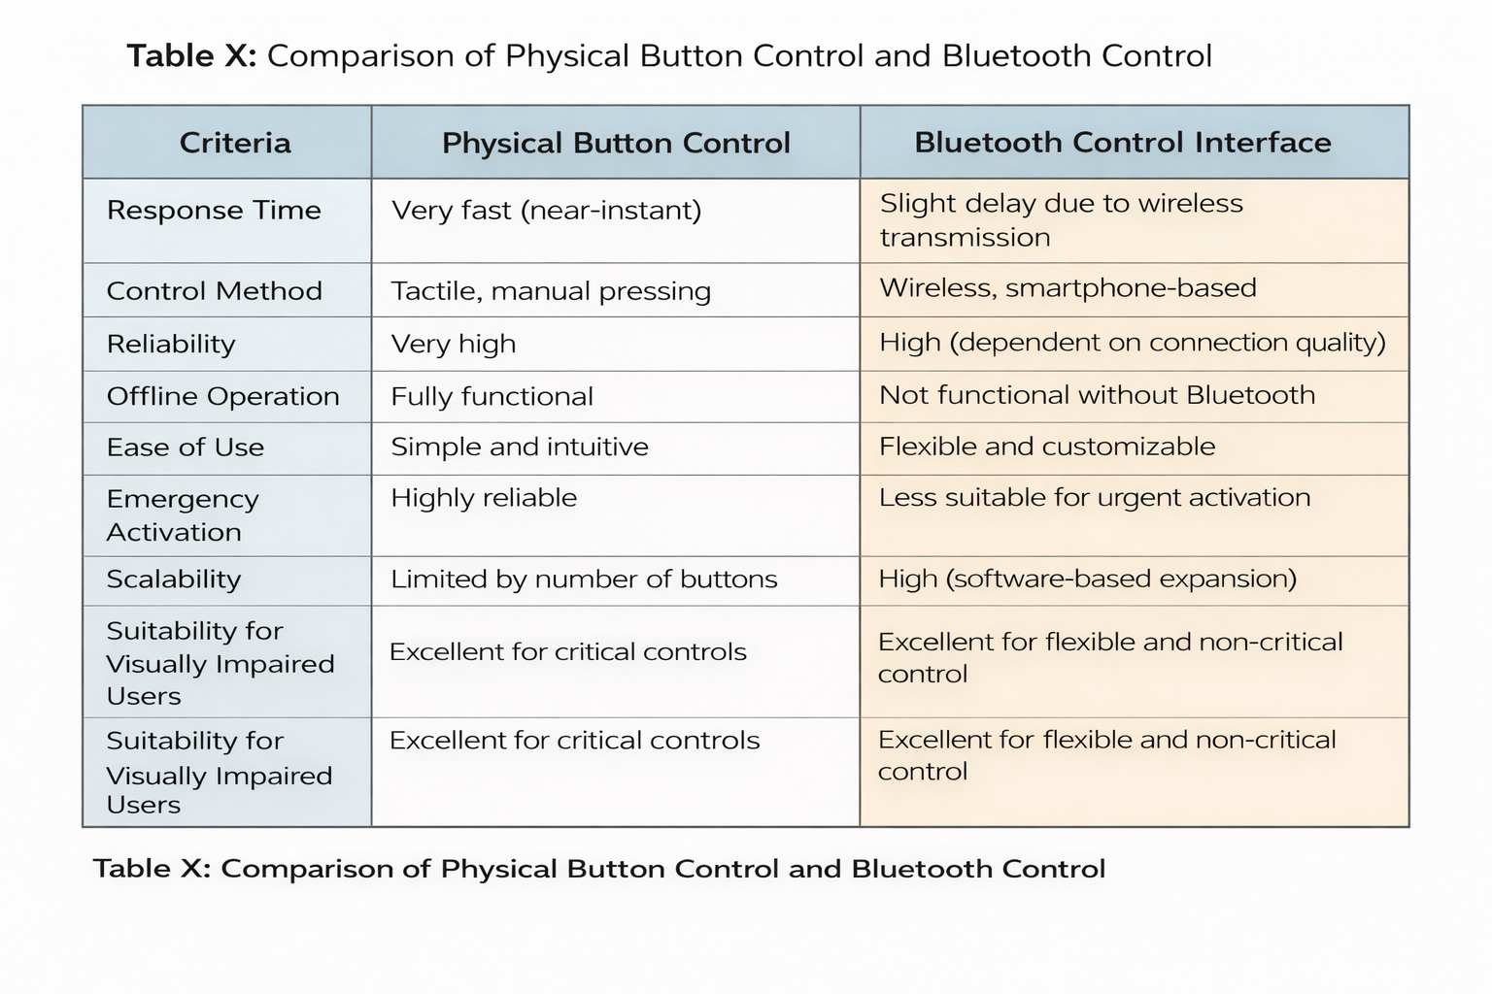
Fig. 6 Comparison of physical button control and bluetooth control interface
3.2 System 2 Local Object Detection and Feedback Performance Analysis

3.2.1 System Architecture and Operation
System 2 serves as the local object detection and feedback module of the proposed Smart Object Finder for visually impaired users. The system enables users to locate a selected target object through real-time, non-visual feedback based on object proximity.

Target object selection is performed either via a physical remote control (System 1) or directly through a smartphone using Bluetooth communication. Once a target is selected, the user pans the handheld device while an onboard HuskyLens AI vision sensor continuously scans the environment. When the detected object matches the selected target, distance information is retrieved and processed by an ESP32 microcontroller to generate appropriate feedback.

3.2.2 Distance-Based Feedback Mechanism
Audio guidance is provided using a buzzer whose activation pattern varies according to object proximity using an ultrasonic sensor. To improve robustness and reduce sensitivity to sensor noise, estimated distances are grouped into discrete proximity categories.

Category | Distance Range | Feedback Pattern
Very Close | < 30 cm | Continuous tone
Close | < 60 cm | Fast intermittent
Medium | < 100 cm | Moderate intermittent
Far | < 200 cm | Slow intermittent
Table 3.1 Displays the distance-feedback range and sound pattern

This distance-based modulation enables intuitive navigation without requiring visual interaction.

3.2.3 Experimental Results and Performance
System performance was evaluated through repeated indoor experiments using both physical button and Bluetooth-based target selection. The system demonstrated reliable object recognition within a 1m range, with minimal false detections due to object-specific training.

The average response time from object detection to buzzer activation was measured to be below 200ms, and no noticeable latency was observed when using Bluetooth input. Distance classification results remained consistent across all defined proximity ranges, validating the effectiveness of categorical distance mapping.

3.2.3 Real-Time Monitoring and Communication

For evaluation and validation purposes, System 2 incorporates real-time monitoring through a Python-based dashboard and Bluetooth-based mobile notifications. The dashboard displays system status, active input source, target object, estimated distance, camera coordinates, and detection history, while mobile notifications provide concise detection summaries.
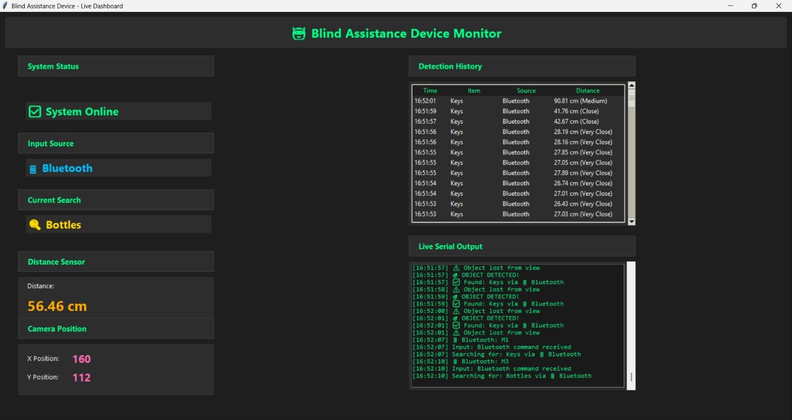
Fig. 7 Real-time data visualization of System 2

3.3 System 3: IoT Communication via Telegram Performance Analysis
This section presents the performance evaluation of the IoT communication subsystem implemented using the Telegram messaging platform. The objective of this subsystem is to enable remote monitoring and event-based notification by transmitting system data from the Smart Object Finder to a remote user in near real time.
3.3.1 Telegram Platform Selection
Telegram was selected as the IoT communication medium due to its open Application Programming Interface (API), low implementation complexity, cross-platform availability, and real-time cloud-based message delivery. Compared to conventional Short Message Service (SMS) or email-based notifications, Telegram offers faster transmission, structured message formatting, and persistent message storage, which are advantageous for assistive technology applications requiring continuous monitoring and user awareness.
In addition, Telegram allows seamless integration with microcontroller platforms through HTTP-based requests, making it suitable for rapid prototyping and deployment in embedded IoT systems.

3.3.2 Data Transmission Process
The data transmission process is initiated when a predefined system event occurs, such as object detection, emergency activation, or system state change. Upon event detection, the microcontroller processes the relevant data and formats it into a structured message. This message is then transmitted via a Wi-Fi connection to the Telegram Bot API, which forwards the notification to the registered user or caregiver.
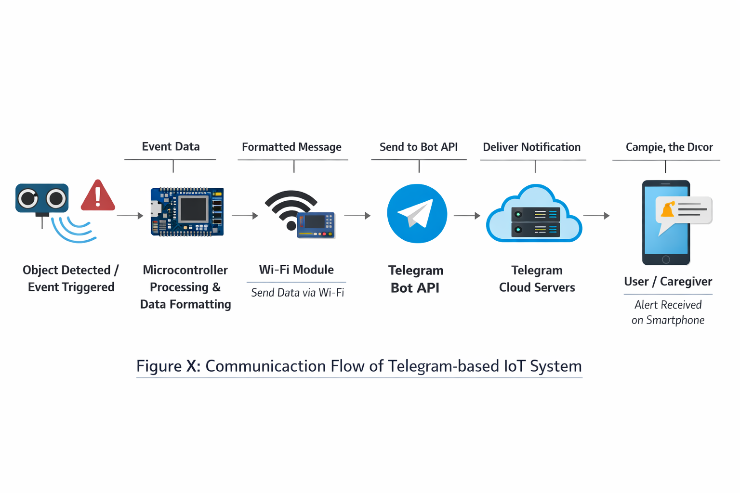
Fig. 8 Communication flow diagram of the Telegram-based IoT system

3.3.3 Message Format
To ensure clarity and usability, transmitted messages follow a standardized format consisting of:
- Event description (e.g., object detected, emergency triggered)
- System status
- Timestamp of occurrence
This structured message format enables users to quickly interpret system notifications without ambiguity.
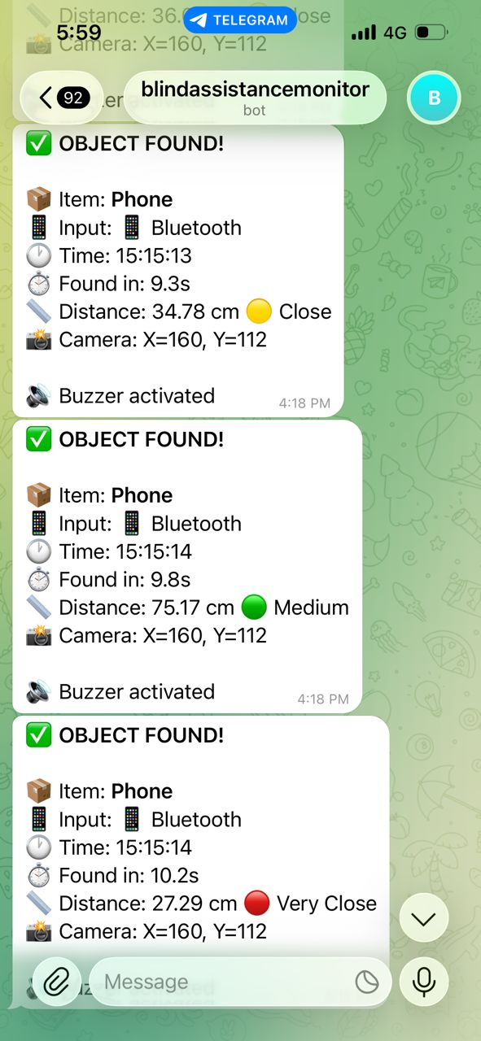
Fig. 9 Telegram notification received by the user

3.3.4 Latency and Message Delay Analysis
Latency performance was evaluated by measuring the time interval between event detection at the system and message reception on the Telegram application. Experimental testing revealed that the average message delivery delay ranged between 3 s and 6 s, depending on network stability and internet bandwidth.
Under stable Wi-Fi conditions, message delivery was consistent and reliable, indicating that the system meets the requirements for non-time-critical alert notifications. Although Telegram communication is not intended for real-time safety-critical control, the observed latency remains acceptable for assistive monitoring and emergency alert applications.
Test Condition | Average Delay (s) | Minimum Delay (s) | Maximum Delay (s)
Stable Wi-Fi | 3.6 | 2.8 | 4.9
Week/ Intermittent Wi-Fi | 5.8 | 4.2 | 8.1
Mobile Data (4G/5G) | 4.0 | 3.4 | 7.2

3.3.5 Reliability and Internet Dependency
Reliability testing showed that all triggered events were successfully delivered to the user when internet connectivity was available. No message loss was observed during testing, demonstrating the robustness of Telegram’s cloud-based infrastructure.
However, the system is inherently dependent on internet availability. In offline conditions, message transmission is delayed or unavailable, which limits system functionality. This dependency highlights a common trade-off in IoT-based assistive systems between accessibility and network reliance.

3.4 Real-Time Data Visualization Analysis

3.4.1 System Overview
System 4 provides real-time visualization and monitoring of System 2 during operation. This system is intended for development, evaluation, and performance validation, rather than direct use by visually impaired users.

The system receives continuous serial data from System 2 and presents both high-level system states and low-level communication logs through a Python-based monitoring interface. In addition, Bluetooth-triggered detection events are reported to a mobile device via asynchronous messaging.

3.4.2 Visualization Platform and Dashboard Structure
Real-time visualization is implemented using a Python-based graphical dashboard running on a personal computer. Data is transmitted from the ESP32 in System 2 via serial communication at 115200 baud.

The dashboard is structured into two primary visual regions:

- System State Panel (left):
Displays real-time operational parameters including the active input source (physical button or Bluetooth), current target object, estimated distance to the detected object, and camera object coordinates.

- Monitoring Panel (center):
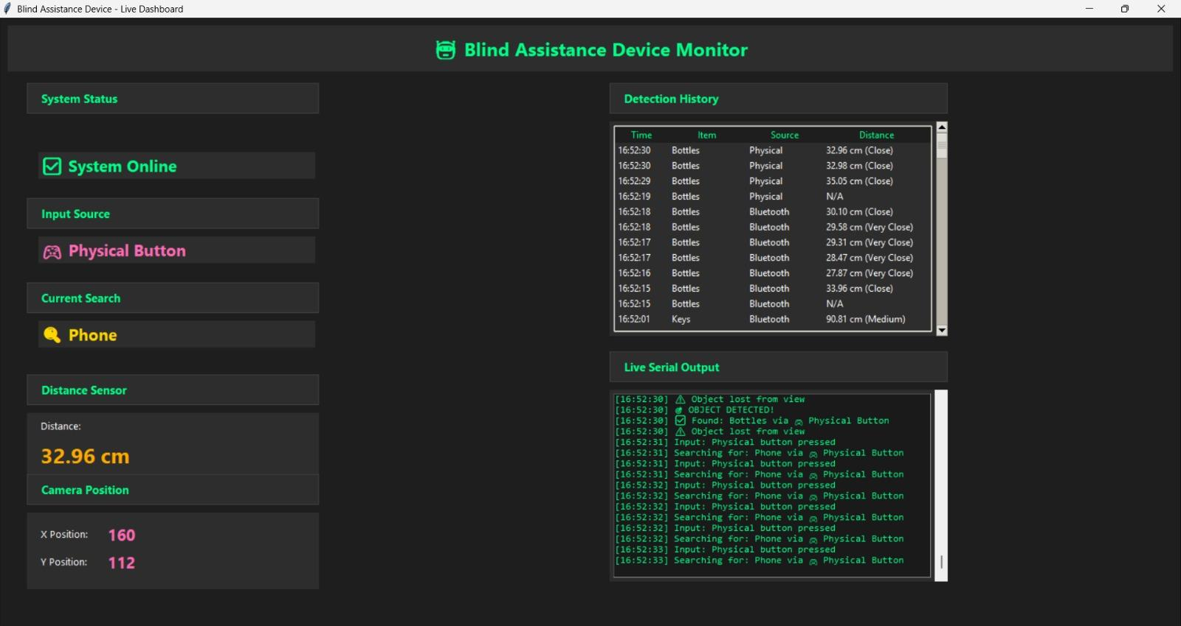
Presents a chronological detection history and live serial output stream, enabling observation of detection events, state transitions, and raw communication data.

Fig. 10 Real-time data visualization of the Smart Object Finder
3.4.3 Real-Time Update Mechanism and Performance
The visualization system processes serial data using a low-latency polling loop, achieving an effective update rate of approximately 10–15 Hz. System responsiveness is enhanced through optimized serial timeout handling and minimal loop delays, allowing near real-time reflection of detection and distance updates.

To prevent system blocking, mobile notifications are transmitted using asynchronous messaging, ensuring that visualization and serial processing remain uninterrupted during Bluetooth-based reporting.

3.4.4 Data Consistency and Accuracy
Displayed distance values, object states, and camera position data were observed to be consistent with sensor outputs from System 2. Minor fluctuations were attributed to changes in camera orientation and object motion; however, these variations did not affect system-level interpretation due to the distance categorization strategy employed in System 2.

The visualization system accurately reflects both physical button and Bluetooth-based input sources, confirming correct multi-input handling.
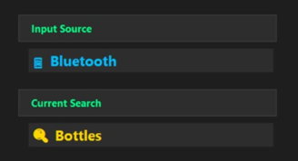
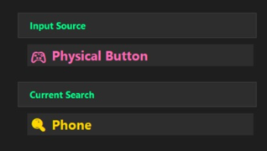
Fig. 11 Real-time data visualization of input source

3.4.4 Evaluation and Usefulness
System 4 provides significant value during system evaluation by enabling:

- Verification of correct input source recognition
- Validation of object detection and distance classification
- Monitoring of system response time and stability
- Inspection of serial communication during real-time operation

Although not intended for end-user interaction, System 4 serves as an essential tool for validating system performance and supporting experimental analysis.
4. DISCUSSION
The Smart Object Finder demonstrates effective integration of multiple subsystems, including local object detection, dual-mode user input, IoT communication, and real-time data visualization. This multi-system architecture enhances both usability and system reliability, which are critical factors in assistive technology design.
The inclusion of both physical buttons and Bluetooth control provides redundancy and flexibility. Physical buttons offer immediate responsiveness and high reliability, particularly in offline scenarios, making them suitable for emergency-related operations. Conversely, Bluetooth control improves user convenience through smartphone integration but introduces dependency on wireless connectivity and potential latency. This trade-off emphasizes the importance of incorporating multiple control modalities to accommodate diverse user and environmental conditions.
The Telegram-based IoT communication system significantly extends system functionality by enabling remote monitoring and alert notification. While this enhances user safety and caregiver awareness, its reliance on internet connectivity remains a limitation. This dependency restricts system operation in network-limited environments and highlights the need for fallback communication mechanisms.
Additionally, the real-time data visualization module improves system transparency by allowing developers and observers to monitor sensor data and system behavior. However, such visualization platforms may require additional computational resources and power consumption, which could affect portability in future implementations.
Overall, the system architecture demonstrates strong scalability potential. Its modular design allows future expansion with minimal structural modification, supporting additional sensing, communication, or intelligent processing features.

5. CONCLUSION
This project successfully developed a Smart Object Finder that integrates AI-based object recognition, ultrasonic distance sensing, dual-mode user input, IoT communication, and real-time monitoring to assist visually impaired users in locating everyday objects. Experimental results demonstrate that physical button input provides fast and reliable offline control, while Bluetooth-based smartphone interaction enhances flexibility and accessibility. The vision-based detection system delivers intuitive distance-based audio feedback, and the IoT and visualization modules support monitoring, validation, and system scalability.
Future work may include the integration of voice-based interaction and haptic feedback to further improve accessibility, expansion of the object recognition database through adaptive learning, and the implementation of offline data logging to reduce internet dependency. User-centered evaluation involving visually impaired participants is also recommended to validate real-world usability and guide further system refinement
Acknowledgement
The authors would like to thank the Mechatronics System Integrations lecturer and laboratory staff for providing the necessary components and technical support for this project.
Conflict of Interest
Authors declare that there is no conflict of interest regarding the publication of the paper.
Author Contribution
The author attests to having sole responsibility for the following: planning and designing the study, data, collection, analysis and interpretation of the outcomes, and paper writing.

6. REFERENCES

[1] M. I. H. Rozaini et al., “Smart Object Finder for the Visually Impaired,” Project Report, IIUM, 2023 (prototype documentation).
[2] N. Dey et al., “Ultrasonic based smart blind stick,” Int. Conf. on Current Trends toward Converging Technologies (ICCTCT), Coimbatore, India, 2018.
[3] K. B. Swain et al., “Arduino based automated stick guide for a visually impaired person,” IEEE Int. Conf. on Smart Technologies and Management (ICSTM), Chennai, India, 2017, pp. 407–410.
[4] U. Pilania et al., “Smart Blind Stick for Blind People,” in Next Generation of Internet of Things (ICNGIoT 2021) – Lect. Notes in Networks and Systems, vol. 201, pp. 13–20. Singapore: Springer, 2021.
[5] A. N. Sridhar et al., “NaviSense: A Multimodal Assistive Mobile Application for Object Retrieval by Persons with Visual Impairment,” arXiv:2509.18672, 2025.
[6] M. Galabov et al., “Smart Canes for the Visually Impaired: Technological Support for Independence and Mobility,” Broad Research in AI and Neuroscience, vol. 16, no. 3, pp. 18–30, 2025.

[7] G. I. Okolo, T. Althobaiti, and N. Ramzan, “Assistive Systems for Visually Impaired Persons: Challenges and Opportunities for Navigation Assistance,” Sensors, vol. 24, no. 11, p. 3572, 2024, doi:10.3390/s24113572.

[8] J. Li, L. Xie, Z. Chen, L. Shi, R. Chen, Y. Ren, L. Wang, and X. Lu, “An AIoT-Based Assistance System for Visually Impaired People,” Electronics, vol. 12, no. 18, p. 3760, 2023, doi:10.3390/electronics12183760.

[9] R. Liu, J. Zhang, A. Schön, K. Müller, J. Zheng, K. Yang, and K. Gerling, “ObjectFinder: Open-Vocabulary Assistive System for Interactive Object Search by Blind People,” arXiv preprint, Dec. 2024.

[10] A. Alarood, M. S. Atoum, A. A. Manaf et al., “Enhanced obstacle detection using bilateral vision-aided transformer neural network for visually impaired persons,” Cluster Comput., vol. 28, p. 997, 2025, doi:10.1007/s10586-025-05740-z.

[11] (Related assistive IoT article) S. Malla, P. K. Sahu, S. Patnaik and A. K. Biswal, “Obstacle detection and assistance for visually impaired individuals using an IoT-enabled smart blind stick,” RIA, vol. 37, no. 3, 2023.

